Graphing exponential and logarithmic functions
F(x) = 5^{x}
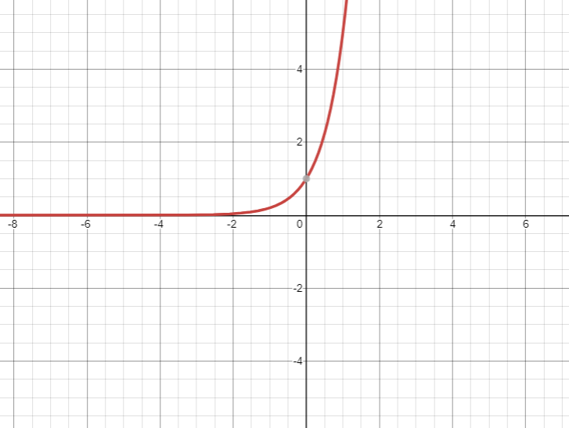

F(x) =5^{-x}
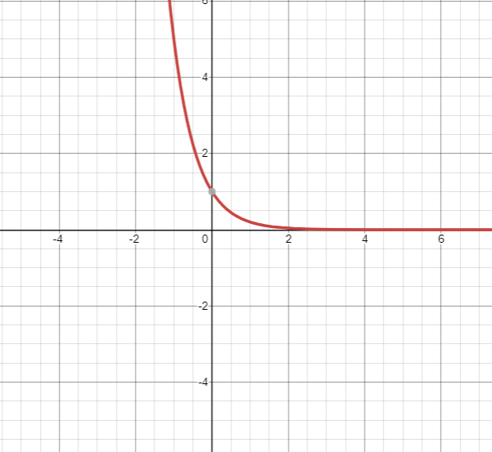

F(x) = log₅x
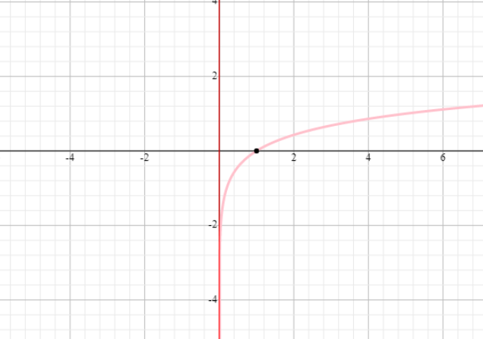

F(x) = log₂x
